ASM OF WASHING MACHINE

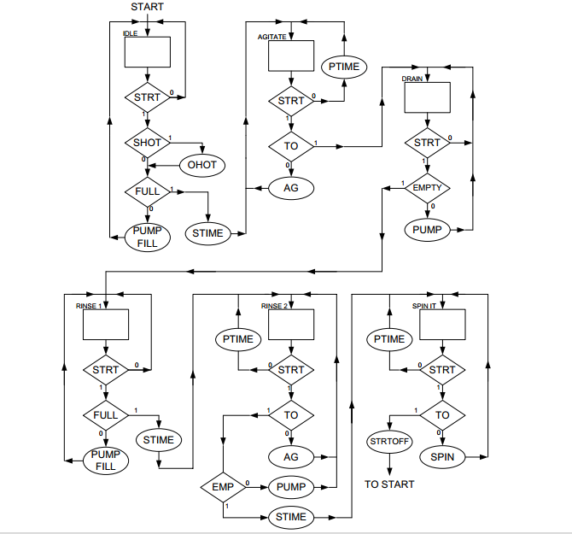 Mohamed Helal